Hive Queries

1. **How many cities that has more than one Emergency Option:**

Select Count(*),HQ.City,HQ.Zipcode from hospitalmaster HQ

Where

lower(HQ.Emergencyservices) ='"yes"'

group by HQ.City,HQ.Zipcode having Count(HQ.HospitalName) >1;

1. **Search Hospital by Name:**

Select HQ.* from hospitalmaster HQ

where

lower(HQ.Emergencyservices) ='"yes"'

AND locate("care",lower(HQ.hospitalname))>0

1. **Hospital with Emergency Option:**

Select HQ.* from hospitalmaster HQ

where lower(HQ.Emergencyservices) ='"yes"';

1. **Search by Zipcode and display its score**

Select HM.Hospitalname, HM.StreetName,HC.Score from hospitalMaster HM

left outer join hospitaltimelyeffectivecare HC on HC.providerid = HM.providerid

where HM.zipcode ='"36301"' and HC.score != '"Not Available"'

1. **Search by “Conditions” like “Chest,pain, stomach, pregnant” and giving its Top 5 results of the score**

Select HQ.HospitalName ,HQ.Condition,HQ.MeasureName ,HQ.SCORE from hospitaltimelyeffectivecare HQ

Where locate("chest",lower(HQ.Condition))>0

AND HQ.SCORE != '"Not Available"'

Order by HQ.SCORE Desc LIMIT 5

**Sample Result:**

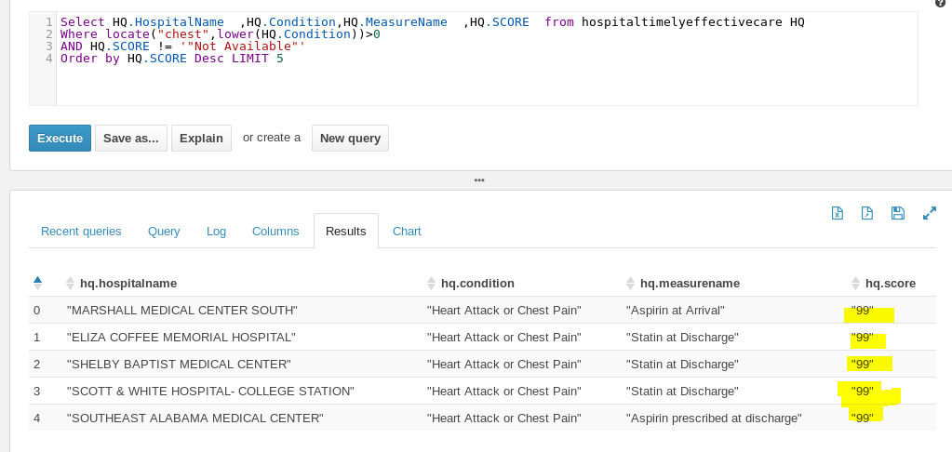

1. **Search by “Conditions” and how many hospitals available each state**

Select Count(*),Hm.State from hospitaltimelyeffectivecare HQ

Left join hospitalmaster HM on HM.providerid = HQ.ProviderID

Where locate("chest",lower(HQ.Condition))>0

and length(HM.State) <=4

group by HM.State Limit 10

Query Result:

